MGMS – User Management

Detailed Design Document

Ver. 1.4

Version History
Date | Description
14-Nov-2010 | First draft

Table of Contents

Version History 2
1 Introduction 4
1.1 Purpose 4
1.2 Scope 4
1.3 Assumptions 4
1.4 Constraints 4
2 User Management 5
1.1. Sub menu – Users List 5
1.2. Sub Menu – Project Permission 6
1.3. Sub menu – Access Permission 7
1.4. Sub Menu – Role Privileges 8
3 Data Dictionary 11

Introduction

Purpose

This document provides the detailed design specifications for the Multisite Grant Management System project.

This is not a project plan nor does it detail the source code. It is a guide for system architecture and development, not for phasing, timelines or deliverables.

Finally, this is a ‘living document’ and the specification will change, continuously, as the project proceeds. More details will be added and the existing information edited as the requirements, architecture and design evolve in the course of the project.

Scope

Assumptions

Constraints

User Management
- The details saved for each user are – Full name, password, email and role in the institution

- A confirmation email with the activation link and login details will be sent to the email address entered during registration.
- Account will get activated by clicking the activation link provided in the email.
- There is an option for the user to change the login password. If the user forgets the password, the system will reset the password and send it to the email entered by the user based on request.

Sub menu – Users List

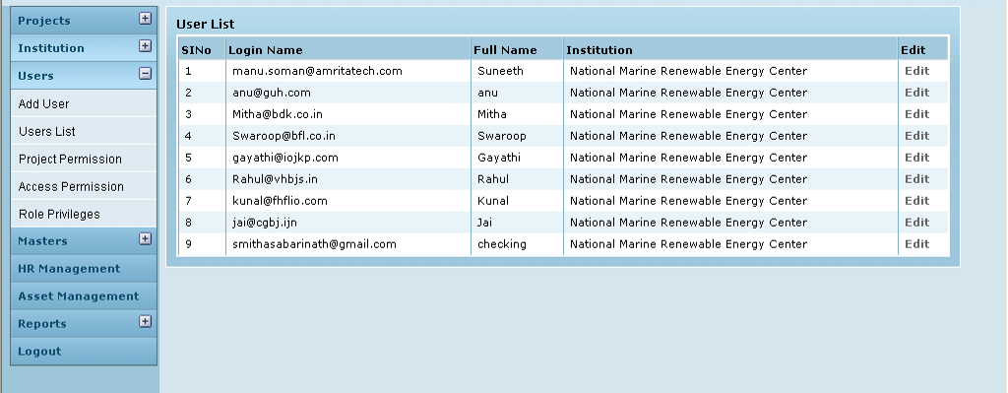

Field /Label | Input-Control | Data Type | Remarks /db table > field
User List
SlNo | Auto populated
Login Name | Auto populated | varchar(255) | person>username
Full Name | Auto populated | varchar(255) | person>user_real_name
Institution | Auto populated | varchar(255) | party>name_of_the_institution
Edit | “Edit” Button

Edit User

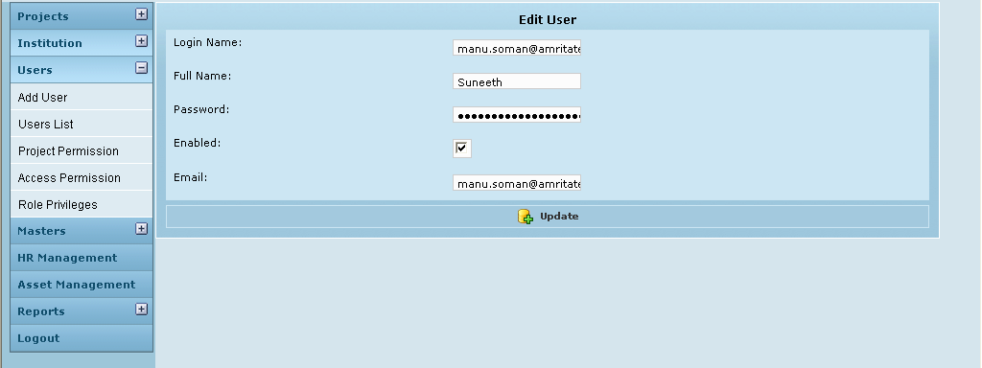

Field /Label | Input-Control | Data Type | Remarks /db table > field
Edit User
Login Name: | Textbox; auto populated & editable | varchar(255) | person>username
Full Name: | Textbox; auto populated & editable | varchar(255) | person>user_real_name
Password: | Textbox; auto populated & editable | varchar(255) | person>password
Enabled: | Checkbox | bit(1) | person>enabled
Email: | Textbox; auto populated & editable | varchar(255) | person>email
Update | Button

Sub Menu – Project Permission

On click the Project Permission tab in the menu list, the screen for giving project access permission will appear. The projects can be viewed /accessed only by the site admin who created those projects.

Here, a new user may be given access to a number of projects all at once, by simply selecting the projects.
Once they are selected, the user can view his list of projects when he logs into the GMS.

- Select the user from the list.
- The siteadmin can assign or unassign the projects to the users by clicking the appropriate direction button.
- To assign the projects select the needed project and click the arrow button towards right hand side and to unassign the projects click the arrow button towards left hand side.

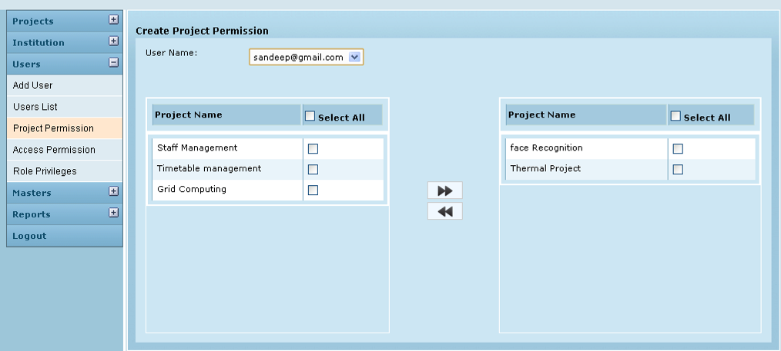
1
2
3
4

- The project which is already assigned to that particular user will be listed in the right hand side.
- The projects which are not already assigned to that particular user will be in the left hand side.

Field /Label | Input-Control | Data Type | Remarks / db table > field
Create Project Permission
User Name: | Listbox | varchar(255) | person>email
Project Name | List | varchar(255) | projects>name
Select All | Checkbox
Label 1 | Checkbox | To select /unselect each unassigned project
Label 2 | Right arrow | To assign the projects select the needed project and click the arrow button towards right hand side and to unassign the projects click the arrow button towards left hand side.
Label 3 | Left arrow
Label 4 | Checkbox | To select /unselect each assigned project

Sub menu – Access Permission

On click the Access Permission tab in the menu list, the screen for giving access permission will appear. The site admin can give privileges on each action to the users on the basis of roles.
This is done with the help of ACL plugin.

.
The site admin can allot the projects to any other users created by that siteadmin.

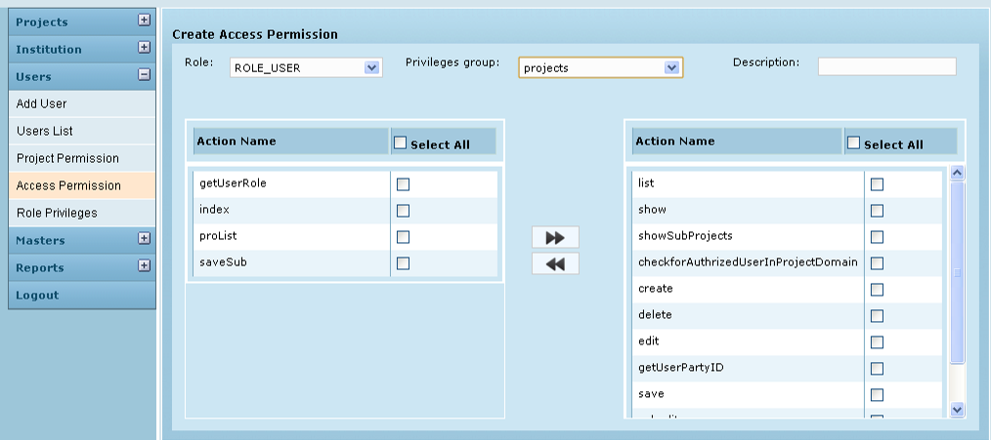
1
2
3
4

The actions under that privilege group on which the selected role had access will be listed in the right hand side
The actions under that privilege group on which the selected role had access will be listed on the left hand side.

Field /Label | Input-Control | Data Type | Remarks / db table > field
Create Access Permission
Role: | Listbox | varchar(255) | authority>authority
Privilege Group | Listbox | varchar(255) | role_privileges>controller_name
Description | Textbox | varchar(255) | role_privileges>description
Action Name | List | varchar(255) | role_privileges>action_name
Select All | Checkbox
Label 1 | Checkbox | To select /unselect each unassigned action
Label 2 | Right arrow | To assign the projects select the needed action privilege and click the arrow button towards right hand side and to unassign the action privilege click the arrow button towards left hand side.
Label 3 | Left arrow
Label 4 | Checkbox | To select /unselect each unassigned action privilege

Sub Menu – Role Privileges

Selecting a role and clicking the create button will give all the privileges to that role.
Field /Label | Input-Control | Data Type | Remarks / db table>field
Create Role Privileges
Authority Name | Listbox | varchar(255) | authority>authority
Create | Button

Make sure that before giving all privileges, that role has no access on any action.

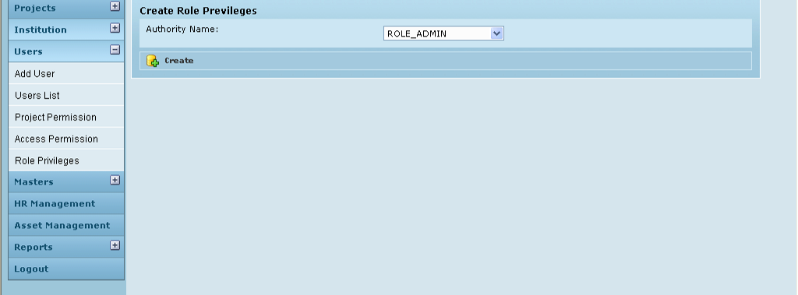

Database Design - Associated Tables

In GMS, there is the need to define access permissions based on security decisions that comprise who Authentication), where (MethodInvocation) and what (SomeDomainObject).The authorization decisions also need to consider the actual domain object instance subject of a method invocation. In GMS, domain object instance security capabilities centre on the concept of an access control list (ACL). Every domain object instance (for e.g., project, grant etc) in the system has its own ACL, and the ACL records details of who can and can't work with that domain object.
The tables are presented below:
- ACL_SID allows us to uniquely identify any principal or authority in the system ("SID" stands for "security identity"). The only columns are the ID, a textual representation of the SID, and a flag to indicate whether the textual representation refers to a principal name or a GrantedAuthority. Thus, there is a single row for each unique principal or GrantedAuthority. When used in the context of receiving a permission, a SID is generally called a "recipient".
- ACL_CLASS allows us to uniquely identify any domain object class in the system. The only columns are the ID and the Java class name. Thus, there is a single row for each unique Class we wish to store ACL permissions for.
- ACL_OBJECT_IDENTITY stores information for each unique domain object instance in the system. Columns include the ID, a foreign key to the ACL_CLASS table, a unique identifier so we know which ACL_CLASS instance we're providing information for, the parent, a foreign key to the ACL_SID table to represent the owner of the domain object instance, and whether we allow ACL entries to inherit from any parent ACL. We have a single row for every domain object instance we're storing ACL permissions for.
- Finally, ACL_ENTRY stores the individual permissions assigned to each recipient. Columns include a foreign key to the ACL_OBJECT_IDENTITY, the recipient (ie a foreign key to ACL_SID), whether we'll be auditing or not, and the integer bit mask that represents the actual permission being granted or denied. We have a single row for every recipient that receives a permission to work with a domain object.
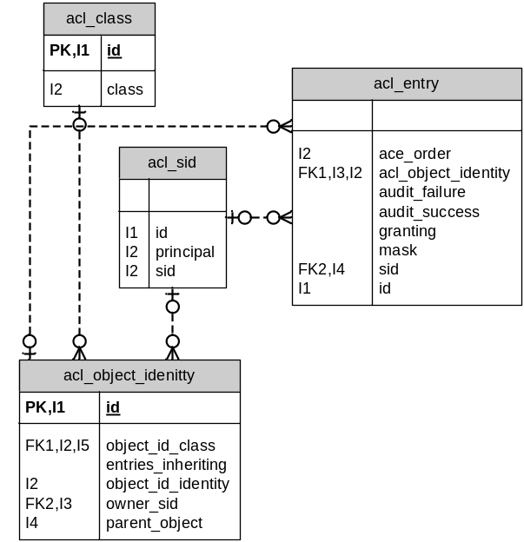

The other associated tables are:

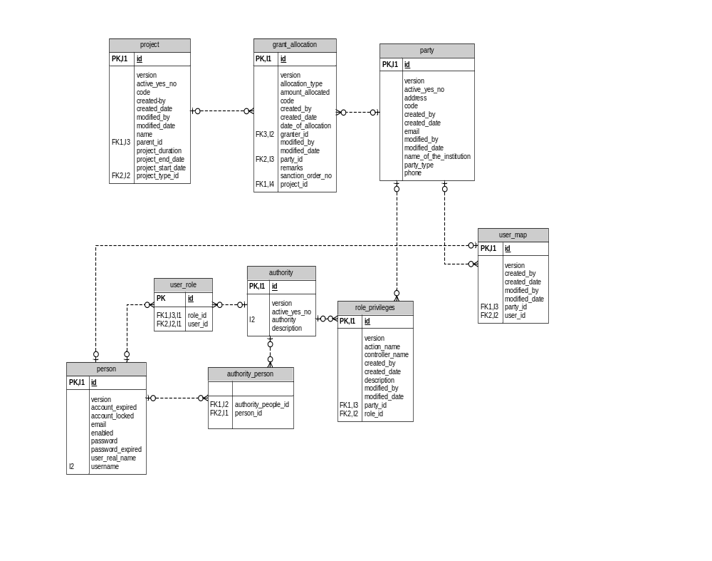

Data Dictionary

acl_class

Fields

Field | Type | Collation | Null | Key | Default | Extra | Privileges
id | bigint(20) | (NULL) | NO | PRI | (NULL) | auto_increment | select,insert,update,references
class | varchar(255) | latin1_swedish_ci | NO | UNI |  |  | select,insert,update,references

Indexes

Table | Non  unique | Key  name | Seq  in  index | Column  name | Collation | Cardinality | Sub  part | Packed | Null | Index  type
acl_class | 0 | PRIMARY | 1 | id | A | 2 | (NULL) | (NULL) |  | BTREE
acl_class | 0 | class | 1 | class | A | 2 | (NULL) | (NULL) |  | BTREE

acl_entry

Fields

Field | Type | Collation | Null | Key | Default | Extra | Privileges
id | bigint(20) | (NULL) | NO | PRI | (NULL) | auto_increment | select,insert,update,references
ace_order | int(11) | (NULL) | NO |  |  |  | select,insert,update,references
acl_object_identity | bigint(20) | (NULL) | NO | MUL |  |  | select,insert,update,references
audit_failure | bit(1) | (NULL) | NO |  |  |  | select,insert,update,references
audit_success | bit(1) | (NULL) | NO |  |  |  | select,insert,update,references
granting | bit(1) | (NULL) | NO |  |  |  | select,insert,update,references
mask | int(11) | (NULL) | NO |  |  |  | select,insert,update,references
sid | bigint(20) | (NULL) | NO | MUL |  |  | select,insert,update,references

Indexes

Table | Non  unique | Key  name | Seq  in  index | Column  name | Collation | Cardinality | Sub  part | Packed | Null | Index  type
acl_entry | 0 | PRIMARY | 1 | id | A | 601 | (NULL) | (NULL) |  | BTREE
acl_entry | 0 | acl_object_identity | 1 | acl_object_identity | A | 601 | (NULL) | (NULL) |  | BTREE
acl_entry | 0 | acl_object_identity | 2 | ace_order | A | 601 | (NULL) | (NULL) |  | BTREE
acl_entry | 1 | FK5302D47DB0D9DC4D | 1 | acl_object_identity | A | 601 | (NULL) | (NULL) |  | BTREE
acl_entry | 1 | FK5302D47D8FDB88D5 | 1 | sid | A | 85 | (NULL) | (NULL) |  | BTREE

Foreign Key Relationships

FK Id |  | Reference Table | Source Column | Target Column |  | Extra Info
FK5302D47D8FDB88D5 |  | acl_sid | `sid` | `id` |  | ,
FK5302D47DB0D9DC4D |  | acl_object_identity | `acl_object_identity` | `id`
acl_object_identity

Fields

Field | Type | Collation | Null | Key | Default | Extra | Privileges
id | bigint(20) | (NULL) | NO | PRI | (NULL) | auto_increment | select,insert,update,references
object_id_class | bigint(20) | (NULL) | NO | MUL |  |  | select,insert,update,references
entries_inheriting | bit(1) | (NULL) | NO |  |  |  | select,insert,update,references
object_id_identity | bigint(20) | (NULL) | NO |  |  |  | select,insert,update,references
owner_sid | bigint(20) | (NULL) | YES | MUL | (NULL) |  | select,insert,update,references
parent_object | bigint(20) | (NULL) | YES | MUL | (NULL) |  | select,insert,update,references

Indexes

Table | Non  unique | Key  name | Seq  in  index | Column  name | Collation | Cardinality | Sub  part | Packed | Null | Index  type
acl_object_identity | 0 | PRIMARY | 1 | id | A | 291 | (NULL) | (NULL) |  | BTREE
acl_object_identity | 0 | object_id_class | 1 | object_id_class | A | 3 | (NULL) | (NULL) |  | BTREE
acl_object_identity | 0 | object_id_class | 2 | object_id_identity | A | 291 | (NULL) | (NULL) |  | BTREE
acl_object_identity | 1 | FK2A2BB00990EC1949 | 1 | owner_sid | A | 22 | (NULL) | (NULL) | YES | BTREE
acl_object_identity | 1 | FK2A2BB009A50290B8 | 1 | parent_object | A | 1 | (NULL) | (NULL) | YES | BTREE
acl_object_identity | 1 | FK2A2BB00970422CC5 | 1 | object_id_class | A | 3 | (NULL) | (NULL) |  | BTREE

Foreign Key Relationships

FK Id | Reference Table | Source Column | Target Column | Extra Info
FK2A2BB00970422CC5 | acl_class | `object_id_class` | `id` | ,
FK2A2BB00990EC1949 | acl_sid | `owner_sid` | `id` | ,
FK2A2BB009A50290B8 | acl_object_identity | `parent_object` | `id`

acl_sid

Fields

Field | Type | Collation | Null | Key | Default | Extra | Privileges
id | bigint(20) | (NULL) | NO | PRI | (NULL) | auto_increment | select,insert,update,references
principal | bit(1) | (NULL) | NO |  |  |  | select,insert,update,references
sid | varchar(255) | latin1_swedish_ci | NO | MUL |  |  | select,insert,update,references

Indexes

Table | Non  unique | Key  name | Seq  in  index | Column  name | Collation | Cardinality | Sub  part | Packed | Null | Index  type
acl_sid | 0 | PRIMARY | 1 | id | A | 44 | (NULL) | (NULL) |  | BTREE
acl_sid | 0 | sid | 1 | sid | A | 44 | (NULL) | (NULL) |  | BTREE
acl_sid | 0 | sid | 2 | principal | A | 44 | (NULL) | (NULL) |  | BTREE

authority

Fields

Field | Type | Collation | Null | Key | Default | Extra | Privileges
id | bigint(20) | (NULL) | NO | PRI | (NULL) | auto_increment | select,insert,update,references
version | bigint(20) | (NULL) | NO |  |  |  | select,insert,update,references
active_yes_no | char(1) | latin1_swedish_ci | NO |  |  |  | select,insert,update,references
authority | varchar(255) | latin1_swedish_ci | NO | UNI |  |  | select,insert,update,references
description | varchar(255) | latin1_swedish_ci | NO |  |  |  | select,insert,update,references

Indexes

Table | Non  unique | Key  name | Seq  in  index | Column  name | Collation | Cardinality | Sub  part | Packed | Null | Index  type
authority | 0 | PRIMARY | 1 | id | A | 10 | (NULL) | (NULL) |  | BTREE
authority | 0 | authority | 1 | authority | A | 10 | (NULL) | (NULL) |  | BTREE

authority_person

Fields

Field | Type | Collation | Null | Key | Default | Extra | Privileges
authority_people_id | bigint(20) | (NULL) | YES | MUL | (NULL) |  | select,insert,update,references
person_id | bigint(20) | (NULL) | YES | MUL | (NULL) |  | select,insert,update,references

Indexes

Table | Non  unique | Key  name | Seq  in  index | Column  name | Collation | Cardinality | Sub  part | Packed | Null | Index  type
authority_person | 1 | FK4C086FD1C12321BA | 1 | person_id | A | 0 | (NULL) | (NULL) | YES | BTREE
authority_person | 1 | FK4C086FD1353431F2 | 1 | authority_people_id | A | 0 | (NULL) | (NULL) | YES | BTREE

Foreign Key Relationships

FK Id | Reference Table | Source Column | Target Column | Extra Info
FK4C086FD1353431F2 | authority | `authority_people_id` | `id` | ,
FK4C086FD1C12321BA | person | `person_id` | `id`

person

Fields

Field | Type | Collation | Null | Key | Default | Extra | Privileges
id | bigint(20) | (NULL) | NO | PRI | (NULL) | auto_increment | select,insert,update,references
version | bigint(20) | (NULL) | NO |  |  |  | select,insert,update,references
account_expired | bit(1) | (NULL) | NO |  |  |  | select,insert,update,references
account_locked | bit(1) | (NULL) | NO |  |  |  | select,insert,update,references
email | varchar(255) | latin1_swedish_ci | NO |  |  |  | select,insert,update,references
enabled | bit(1) | (NULL) | NO |  |  |  | select,insert,update,references
password | varchar(255) | latin1_swedish_ci | NO |  |  |  | select,insert,update,references
password_expired | bit(1) | (NULL) | NO |  |  |  | select,insert,update,references
user_real_name | varchar(255) | latin1_swedish_ci | NO |  |  |  | select,insert,update,references
username | varchar(255) | latin1_swedish_ci | NO | UNI |  |  | select,insert,update,references
user_sur_name | varchar(255) | latin1_swedish_ci | YES |  | (NULL) |  | select,insert,update,references

Indexes

Table | Non  unique | Key  name | Seq  in  index | Column  name | Collation | Cardinality | Sub  part | Packed | Null | Index  type
person | 0 | PRIMARY | 1 | id | A | 99 | (NULL) | (NULL) |  | BTREE
person | 0 | username | 1 | username | A | 99 | (NULL) | (NULL) |  | BTREE

role

Fields

Field | Type | Collation | Null | Key | Default | Extra | Privileges
id | bigint(20) | (NULL) | NO | PRI | (NULL) | auto_increment | select,insert,update,references
version | bigint(20) | (NULL) | NO |  |  |  | select,insert,update,references
authority | varchar(255) | latin1_swedish_ci | NO | UNI |  |  | select,insert,update,references
description | varchar(255) | latin1_swedish_ci | NO |  |  |  | select,insert,update,references

Indexes

Table | Non  unique | Key  name | Seq  in  index | Column  name | Collation | Cardinality | Sub  part | Packed | Null | Index  type
role | 0 | PRIMARY | 1 | id | A | 0 | (NULL) | (NULL) |  | BTREE
role | 0 | authority | 1 | authority | A | 0 | (NULL) | (NULL) |  | BTREE

role_privileges

Fields

Field | Type | Collation | Null | Key | Default | Extra | Privileges
id | bigint(20) | (NULL) | NO | PRI | (NULL) | auto_increment | select,insert,update,references
version | bigint(20) | (NULL) | NO |  |  |  | select,insert,update,references
action_name | varchar(255) | latin1_swedish_ci | NO |  |  |  | select,insert,update,references
controller_name | varchar(255) | latin1_swedish_ci | NO |  |  |  | select,insert,update,references
created_by | varchar(255) | latin1_swedish_ci | YES |  | (NULL) |  | select,insert,update,references
created_date | datetime | (NULL) | YES |  | (NULL) |  | select,insert,update,references
description | varchar(255) | latin1_swedish_ci | YES |  | (NULL) |  | select,insert,update,references
modified_by | varchar(255) | latin1_swedish_ci | YES |  | (NULL) |  | select,insert,update,references
modified_date | datetime | (NULL) | YES |  | (NULL) |  | select,insert,update,references
party_id | bigint(20) | (NULL) | NO | MUL |  |  | select,insert,update,references
role_id | bigint(20) | (NULL) | NO | MUL |  |  | select,insert,update,references

Indexes

Table | Non  unique | Key  name | Seq  in  index | Column  name | Collation | Cardinality | Sub  part | Packed | Null | Index  type
role_privileges | 0 | PRIMARY | 1 | id | A | 208956 | (NULL) | (NULL) |  | BTREE
role_privileges | 1 | FK797EEF4B2177BCA7 | 1 | role_id | A | 8 | (NULL) | (NULL) |  | BTREE
role_privileges | 1 | FK797EEF4B4B78CFDA | 1 | party_id | A | 224 | (NULL) | (NULL) |  | BTREE

Foreign Key Relationships

FK Id | Reference Table | Source Column | Target Column | Extra Info
FK797EEF4B4B78CFDA | party | `party_id` | `id` | ,
FK797EEF4B2177BCA7 | authority | `role_id` | `id`

user_map

Fields

Field | Type | Collation | Null | Key | Default | Extra | Privileges | Comment
id | bigint(20) | (NULL) | NO | PRI | (NULL) | auto_increment | select,insert,update,references
version | bigint(20) | (NULL) | NO |  |  |  | select,insert,update,references
created_by | varchar(255) | latin1_swedish_ci | NO |  |  |  | select,insert,update,references
created_date | datetime | (NULL) | YES |  | (NULL) |  | select,insert,update,references
modified_by | varchar(255) | latin1_swedish_ci | NO |  |  |  | select,insert,update,references
modified_date | datetime | (NULL) | YES |  | (NULL) |  | select,insert,update,references
party_id | bigint(20) | (NULL) | NO | MUL |  |  | select,insert,update,references
user_id | bigint(20) | (NULL) | NO | MUL |  |  | select,insert,update,references

Indexes

Table | Non  unique | Key  name | Seq  in  index | Column  name | Collation | Cardinality | Sub  part | Packed | Null | Index  type | Comment
user_map | 0 | PRIMARY | 1 | id | A | 113 | (NULL) | (NULL) |  | BTREE
user_map | 1 | FKF022E2E885837584 | 1 | user_id | A | 113 | (NULL) | (NULL) |  | BTREE
user_map | 1 | FKF022E2E84B78CFDA | 1 | party_id | A | 113 | (NULL) | (NULL) |  | BTREE

Foreign Key Relationships

FK Id | Reference Table | Source Column | Target Column | Extra Info
FKF022E2E84B78CFDA | party | `party_id` | `id` | ,
FKF022E2E885837584 | person | `user_id` | `id`

user_role

Fields

Field | Type | Collation | Null | Key | Default | Extra | Privileges | Comment
role_id | bigint(20) | (NULL) | NO | PRI |  |  | select,insert,update,references
user_id | bigint(20) | (NULL) | NO | PRI |  |  | select,insert,update,references

Indexes

Table | Non  unique | Key  name | Seq  in  index | Column  name | Collation | Cardinality | Sub  part | Packed | Null | Index  type | Comment
user_role | 0 | PRIMARY | 1 | role_id | A | 16 | (NULL) | (NULL) |  | BTREE
user_role | 0 | PRIMARY | 2 | user_id | A | 115 | (NULL) | (NULL) |  | BTREE
user_role | 1 | FK143BF46A85837584 | 1 | user_id | A | 115 | (NULL) | (NULL) |  | BTREE
user_role | 1 | FK143BF46A2177BCA7 | 1 | role_id | A | 16 | (NULL) | (NULL) |  | BTREE

Foreign Key Relationships

FK Id | Reference Table | Source Column | Target Column | Extra Info
FK143BF46A2177BCA7 | authority | `role_id` | `id` | ,
FK143BF46A85837584 | person | `user_id` | `id`

